Local Testing Sites
IF YOU HAVE SYMPTOMS OF COVID-19,
PLEASE CALL YOUR HEALTHCARE
PROVIDER OR GET TESTED
Polk County Public Health | 218 281 3385
Norman-Mahnomen Public Health | 218 784 5425

Altru Health | All Locations
Call Coronavirus Hotline at 701.780.6358 to schedule an appointment

Crookston National Guard Armory | 1801 University Avenue | Crookston | MN
12:00pm - 6:00pm | Various Dates Appointment Preferred, Walk-ins Available
Schedule at: https://mncovidtestingappt.as.me/schedule.php

CVS Pharmacy Drive Up | 1714 Center Avenue | Dilworth | MN
Appointments Needed and Insurance Card & Proof of Identity - REQUIRED Schedule at: https://www.cvs.com/minuteclinic/covid-19-testing

Essentia Health | All locations
Schedule an appointment in your MyChart or call the COVID hotline at 833.494.0836

Legacy Medical | 322 Demers Ave | Grand Forks | ND
Call or text 701.330.4236 to schedule an appointment

4/27/21

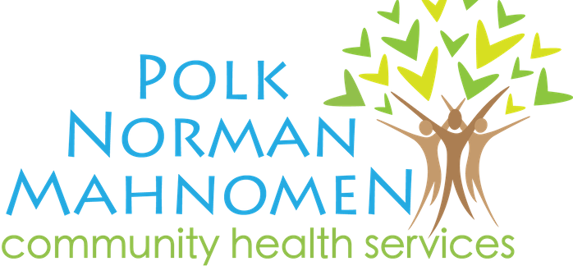New American Integration Center | 1401 Central Ave NE Suite 3 | East Grand Forks | MN
TOGETHER WE CAN find answers.
12:00pm-5:00pm | Various Dates
Call 218.693.9727 to schedule an appointment

North Valley Health Center | 300 West Good Samaritan Drive | Warren | MN
Call 218.745.4211 to schedule an appointment

Riverview Health | All Locations
Call Coronavirus Nurse Screening Line at 218.470.7983 to schedule an appointment

Sanford Health | All Locations
Call your clinic or sign-in to do an e-visit.

University of North Dakota | Grand Forks | ND
Various dates and times
Preregister: https://und.edu/covid-19/testing.html

Vault Health | Thomas Edison Building | 1110 S. 14th Street | Moorhead | MN
Various Dates | Walk-in Appointments Available
Schedule at: https://mncovidtestingappt.as.me/schedule.php

White Earth Nation
Call 833.989.2873 to schedule an appointment.
AT HOME TESTING:
To get started: https://learn.vaulthealth.com/state-of-minnesota/
You will need an email address or phone number to receive test results

